Example Problems

[1] Define both absolute and comparative advantage

Use the following information to answer question 2 – 5

The United States and France both make airplanes and cars. In the United States 500 labor hours are needed to make one airplane and 100 labor hours are need to make one car. In France 400 labor hours are needed to make one airplane and 50 labor hours are needed to make one car.

[2] Which country has the absolute advantage in producing cars? Make sure to state why.

[4] Which country has the comparative advantage in producing cars? Make sure to state why.

[5] Which country should specialize in and export cars and in turn import airplanes? Make sure to state why.

[6] For the country specializing and exporting airplanes describe a trade ratio that would be mutually beneficial for both countries.

____ cars in exchange for 1 airplane

The figure below shows the domestic supply and demand curves for Textiles for the small country of Econoland. Where P denotes prices and Q denotes quantities. Use this information to answer questions 7 – 13.

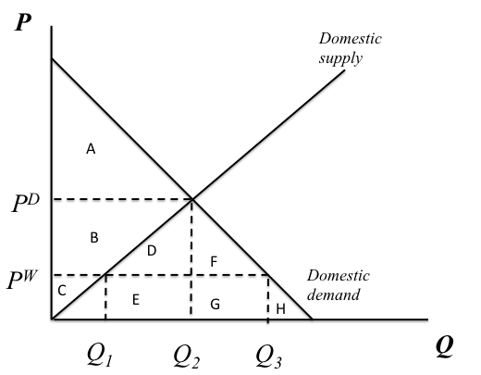

[7] If Econoland does not trade with other countries what is domestic price and quantity of textiles in equilibrium? [choose between P^{D}, P^{W}, Q₁, Q₂, Q₃]

[8] If Econoland does not trade with other countries what areas represent consumer surplus, producer surplus and total surplus?

[9] Suppose the world price of textiles (outside of the small country of Econoland) is P^{W}. If Econoland engages in international trade will it import textiles, export textiles or neither? If they import or export textiles, indicate how many units.

[10] If Econoland engages in international trade what quantity represents domestic demand for textiles?

[11] If Econoland engages in international trade what areas represent consumer surplus, producer surplus and total surplus?

[12] If Econoland engages in international trade what are the total gains from trade for Econoland?

[13] Suppose Econoland considers putting a tariff on imports of textiles from other countries. If the tariff is imposed what will happen to the price of textiles domestically, the quantity supplied domestically and the quantity demanded domestically? [Indicate whether each goes up, down or stays the same]

[14] Suppose the current spot rate is E€/$ = 0.80. What is the exchange rate in “American Terms”?

[15] Suppose the spot rate is E€/$ = 0.80 in January and is E€/$ = 0.96 in December of the same year. Has the euro appreciated, depreciated or stayed the same against the dollar?

[16] Suppose the spot rate is E€/$ = 0.80 in January and is E€/$ = 0.96 in December of the same year. What is the percentage change in exchange rates in “European Terms”?

[17] Suppose E€/£ = 1.14 and E€/$ = 0.90. What is the “indirect” exchange rate between pounds and dollars E£/$?

[18] Suppose E€/£ = 1.14 and E€/$ = 0.90. Also suppose the current spot rate is E£/$ = 0.75. If you have $1,000 to start with how can you make a profit and how much is the profit?

[19] Describe Gresham’s Law. In other words, describe why bad money drives out good money in an economy.

[20] The price for a Big Mac in France is 5 euros and the price for a Big Mac in the U.S. is 4 dollars. Assuming that purchasing power parity holds, what is the spot exchange rate?

[21] Which countries currencies are included in the basket that determines the value of the IMF’s special drawing rights (SDRs)?

[22] Describe how an “option” works in the ForEx market.

[23] Consider France in the 1960s. France pegged the franc to the U.S. dollar, which was pegged to gold. Explain how France could use reserves to maintain a peg of its currency to the U.S. dollar.

[24] What determines how many votes a member country to the IMF gets?

[25] If a country’s currency depreciates, is the Trade Balance (Exports - Imports) more likely to increase or decrease? Explain why.

[26] The price for a Big Mac in France is 5 euros and the price for a Big Mac in the U.S. is 4 dollars. Assuming the spot exchange rate is 1, what is the real exchange rate in “American Terms”?

Comparing the nominal exchange rate of 1 with the real exchange rate, is the US dollar undervalued or overvalued relative to the euro?

